TEMPLATE FOR USING CHEAP YELLOW DISPLAY WITH SQUARELINE STUDIO AND PLATFORMIO ARDUINO FRAMEWORK

(This readme contributed by <https://github.com/amirzohaib> to which I added some more edits and graphics)

**Extract:**  
Extract the zip to a folder where you wish to keep your new project.  
(You may want to keep a folder just for the template and duplicate that for each new project).  
  
In Visual Studio Code with Platformio, open the template folder with 'Open Project' or ‘Open folder’  
When you first open the folder containing this template, platformio will ask to build the project,  
click yes and it will download the necessary libraries and dependencies.  
you might need to install a GIT downloader if download fails

**Copy lv_conf.h and replace User_Setup.h:**  
These files have been modified to work with CYD,  
These files are in the directory "NECESARY TEMPLATE FILES"  
  
 copy lv_conf.h to .pio\libdeps\cyd\lv_conf.h  
 copy and replace User_Setup.h to .pio\libdeps\cyd\TFT_eSPI  
 (these paths are noted in the comment at the top of each file)

**Test the Template:**  
This template includes a simple project from Squareline Studio ("SLS")  
The project has a blue button. When it is pressed, the ball will drop and bounce off the button.  
It is already in the src/ui directory. You can build and upload this project to your CYD as a test if you like.  
  
Build/upload your project to the cyd board.   
(There are several ways to do this… here is one: Click Platform IO - Project Tasks - cyd - General – Upload) Note that there cannot be any monitors (such as Putty or CoolTerm) connected to cyd while you are trying to upload the binary to the cyd.  
  
***Check that all of the fonts you used in the SLS project are turned on.***   
 These start at line 366 of lv_conf.h  
 "1" indicates that you need the font, "0" indicates that you do not need the font.  
For this example you will need #define LV_FONT_MONTSERRAT_16 1 in your lv_conf

**CYD2USB Variant:**  
For Much better colors on the CYD2USB Variant, add all this to the void setup() in main.cpp

tft.setRotation(1); // Landscape orientation 1 = CYC usb on right, 2 for ver  
tft.invertDisplay(1); // if your colors are inverted  
tft.writecommand(ILI9341_GAMMASET); //Gamma curve selected  
tft.writedata(2);  
delay(120);  
tft.writecommand(ILI9341_GAMMASET); //Gamma curve selected  
tft.writedata(1);

**Create and Upload your own Square Line Studio (SLS) Project:**Make sure your project has the following Settings (/File/Project Settings)  
Width:320  
Height: 240  
Depth: 16-bit  
Board Group: Arduino  
Board: Arduino with TFT_eSPI (Note the LVGL Version, make sure its the same as in platfomio.ini lib-dep)  
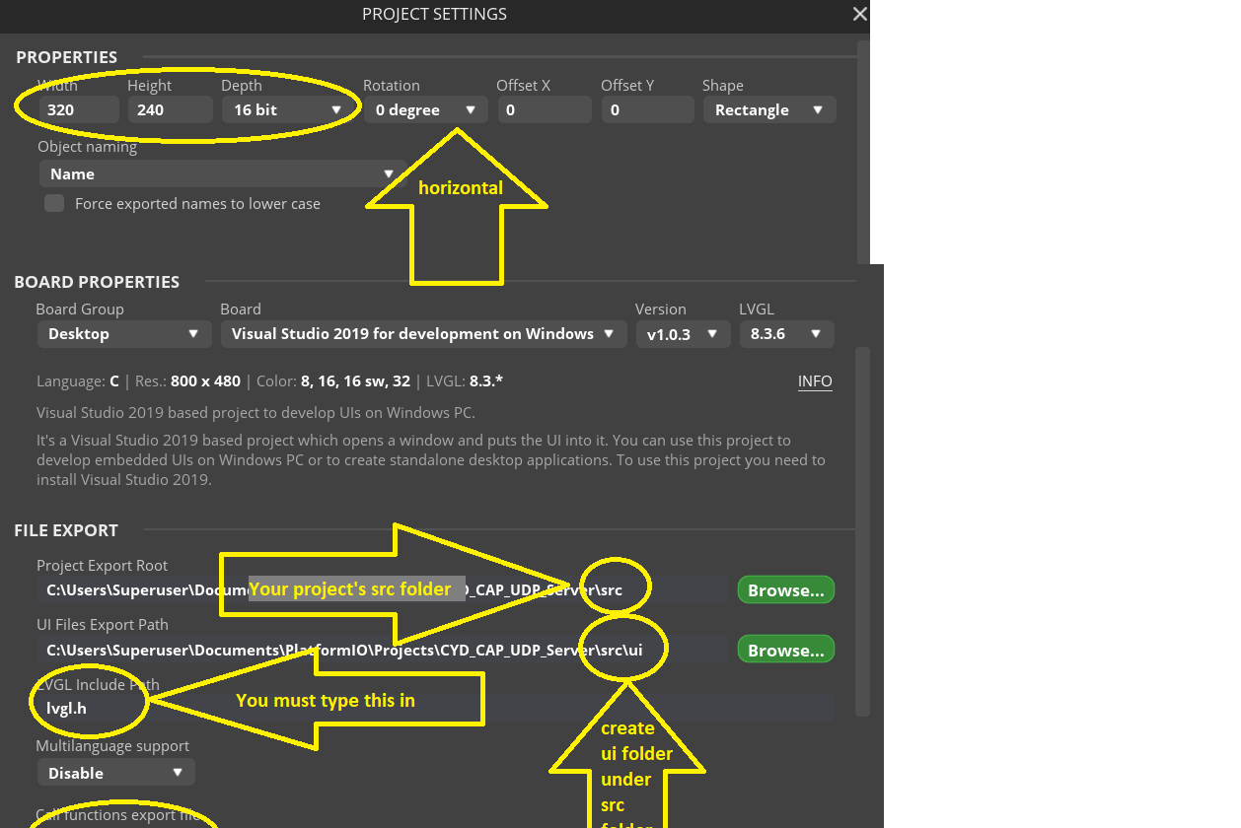  
Set the Project Export Root to your project’s src folder. For example C:\Users\owner\Documents\PlatformIO\Projects\CYD Project\src  
  
Set UI Files Export Path: the path to your projects's src/ui folder.  
for example: C:\Users\owner\Documents\PlatformIO\Projects\CYD Project\src\ui  
  
Set LVGL Include Path to lvgl.h (you will see an example in gray (lvgl/lvgl.h)   
*YOU MUST TYPE OVER THIS* lvgl.h  
  
From the Template folder, go to \src\ui and delete everything  
You will be exporting your SLS ui into that directory and replacing the ball example.  
  
Also note that if you are setting up a project from scratch, you will need to match the version of lgvl that you load in platformio.ini with the setting in the SLS create project screen. In the code provided here, that version is 8.3.6

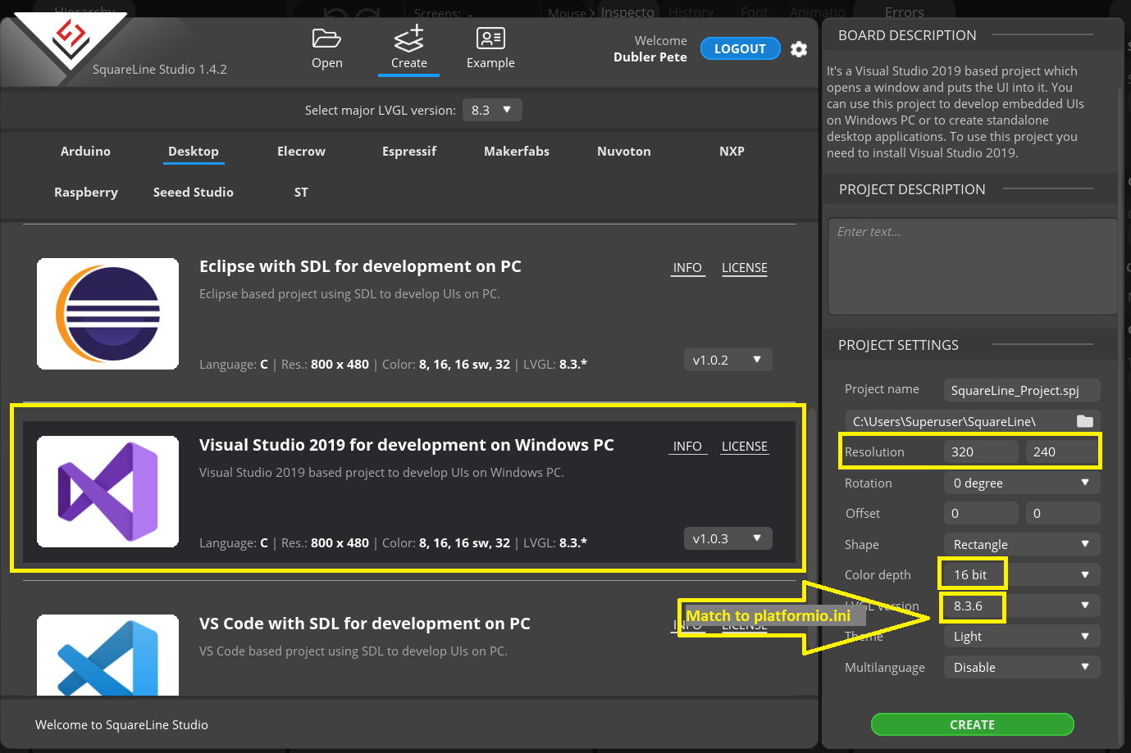  
  
You should now be able to build your project and further edit the main.cpp code to add necessary real-world interfaces, etc.